**1-way Independent ANOVA**

n = _____

K = _____

nT = _____

Setup: Started with 18 subjects, randomly divided them into three groups of six.

Each group was given a type of word list to later recall.

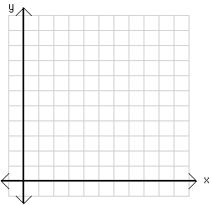

Means Plot

**dfTOTAL**

( nT – 1 )

**dfBet-group**

( k – 1 )

**dfWith-group**

( nT – k )

|  |  |  |
| --- | --- | --- |
| Neutral | Positive | Negative |
| 20  16  8  17  15  10 | 21  18  7  15  10  4 | 17  11  4  18  13  10 |
| MNeu = 14.33  SNeu = 4.50 | MPos = 12.5  SPos = 6.60 | MNeg = 12.17  SNeg = 5.12 |

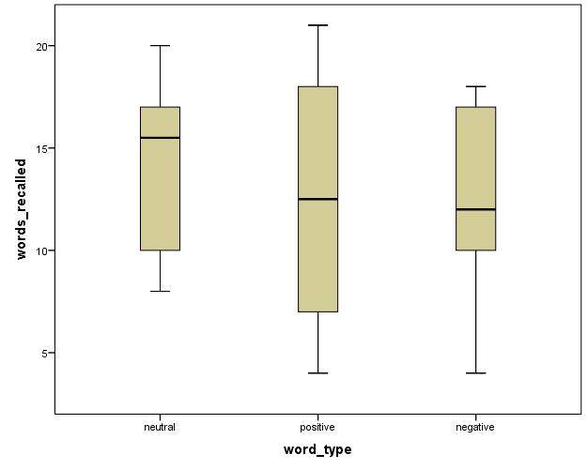

|  |  |  |  |  |  |
| --- | --- | --- | --- | --- | --- |
| Source | SS | df | MS | F | p |
| Between-Groups |  |  |  |  |  |
| Within-Groups (**Residual**) |  |  |  |  |  |
| Total |  |  |  | *Fcrit(___, ___) = ______* | |

**2-way Independent ANOVA**

n = _____

c = _____

r = _____

nT = _____

Setup: Started with 18 subjects, 9 with preexisting depression & 9 without.

Randomly divided each set of 9 them into three groups of three.

Each group was given a type of word list to later recall.

**dfTOTAL**

( nT – 1 )

**dfBet-Cell**

( rc – 1 )

**dfWith-Cell**

( nT – rc )

**dfRow**

( r – 1 )

**dfCol**

( c - 1 )

**dfRow x Col**

( r - 1)*( c - 1 )

|  |  |  |  |  |  |  |  |
| --- | --- | --- | --- | --- | --- | --- | --- |
|  | Neutral | | Positive | | Negative | |  |
| Depressed | 20  16  8 | M = 14.67  S = 6.11 | 21  18  7 | M = 15.33  S = 7.37 | 17  11  4 | M = 10.67  S = 6.51 | MDep = 13.56 |
| Not depressed | 17  15  10 | M = 14.00  S = 3.61 | 15  10  4 | M = 9.67  S = 5.51 | 18  13  10 | M = 13.67  S = 4.04 | MNot = 12.44 |
|  | MNeu = 14.33 | | MPos = 12.5 | | MNeg = 12.17 | | MGrand = 13 |



Means Plot

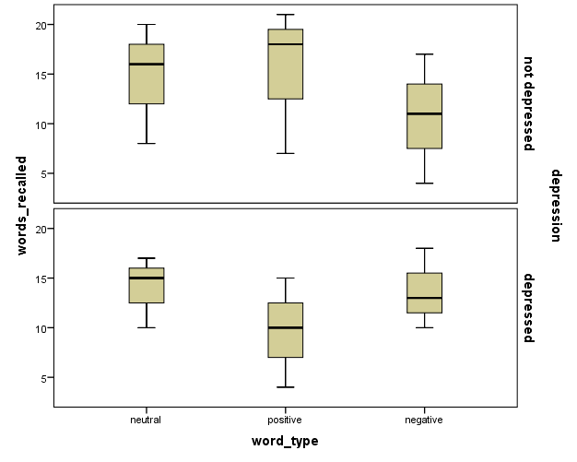

|  |  |  |  |  |  |
| --- | --- | --- | --- | --- | --- |
| Source | SS | Df | MS | F | p |
| Between-Cells |  |  |  |  |  |
| Row Groups |  |  |  |  |  |
| Column Groups |  |  |  |  |  |
| INTER (Row x Col) |  |  |  |  |  |
| Within-Cells (**Residual**) |  |  |  | *Fcrit(___, ___) = ______*  *Fcrit(___, ___) = ______* | |
| Total |  |  |  |

**1-way Repeated Measures ANOVA**

n = _____

c = _____

nT = _____

Setup: Started with 6 subjects, were each given all 3 type of word list to later recall.

The words were actually all randomly included on the same list.

**DfRM**

( c – 1 )

**DfSubxRM**

( n - 1)( c – 1 )

**dfTOTAL**

( nT – 1 )

**dfBet-Sub**

( n – 1 )

**dfWith-Sub**

n( c – 1 )

|  |  |  |  |  |  |  |  |
| --- | --- | --- | --- | --- | --- | --- | --- |
|  | |  | | Neutral | Positive | Negative |  |
| Subject ID | | 1 | 20 | 21 | 17 | M1 = 19.33 |
| 2 | 16 | 18 | 11 | M2 = 15.00 |
| 3 | 7 | 7 | 4 | M3 = 6.33 |
| 4 | 15 | 15 | 18 | M4 = 16.67 |
| 5 | 10 | 10 | 13 | M5 = 12.67 |
| 6 | 4 | 4 | 10 | M6 = 8.00 |
|  | |  | MNeu = 14.33 | MPos = 12.5 | MNeg = 12.17 | MGrand = 13 |

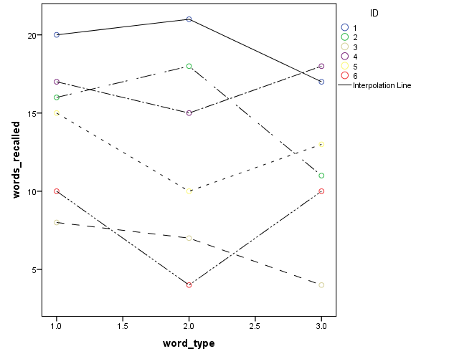

**Shpericity violated? Now what?**

|  |  |  |  |  |  |
| --- | --- | --- | --- | --- | --- |
| Source | SS | df | MS | F | p |
| Between-Subjects |  |  |  |  |  |
| Within-Subjects |  |  |  |  |  |
| RM |  |  |  |  |  |
| **Residual**: INTER(RM x Sub) |  |  |  | *Fcrit(___, ___) = ______* | |
| Total |  |  |  |

**2-way Mixed Design ANOVA**

n = _____

k = _____

c = _____

nT = _____

Setup: Started with 6 subjects, 3 with preexisting depression & 3 without.

All were each given all 3 type of word list to later recall.

**dfTOTAL**

( nT – 1 )

**dfBet-Sub**

( nk – 1 )

**dfWith-Sub**

nk( c – 1 )

**dfRM**

( c – 1 )

**dfSub x RM**

k( c - 1 )( n - 1)

**dfGroup x RM**

( k - 1)*( c - 1 )

|  |  |  |  |  |  |  |  |  |
| --- | --- | --- | --- | --- | --- | --- | --- | --- |
|  |  | Neutral | | Positive | | Negative | |  |
| Depressed | 1 | 20 | M = 14.67 | 21 | M = 15.33 | 17 | M = 10.67 | MDep = 13.56 |
| 2 | 16 | 18 | 11 |
| 3 | 8 | 7 | 4 |
| Not depressed | 4 | 17 | M = 14.00 | 15 | M = 9.67 | 18 | M = 13.67 | MNot = 12.44 |
| 5 | 15 | 10 | 13 |
| 6 | 10 | 4 | 10 |
|  |  | MNeu = 14.33 | | MPos = 12.5 | | MNeg = 12.17  **dfGroup**  ( k – 1 )  **dfWith-group**  k( n - 1 ) | | MGrand = 13 |

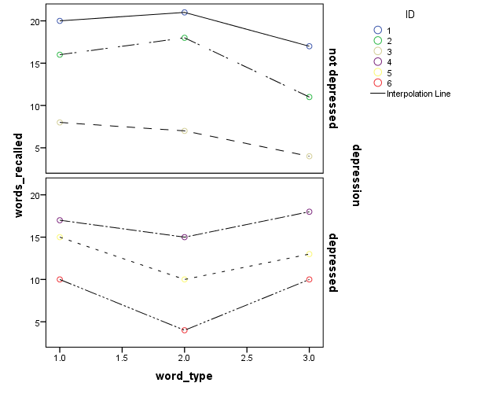

|  |  |  |  |  |  |
| --- | --- | --- | --- | --- | --- |
| Source | SS | df | MS | F | p |
| Between-Subjects |  |  |  |  |  |
| Groups |  |  |  |  |  |
| **Residual**: Within-Groups |  |  |  |  |  |
| Within-Subjects |  |  |  |  |  |
| RM |  |  |  |  |  |
| INTER: Group x RM |  |  |  |  |  |
| **Residual**: INTER(Sub x RM) |  |  |  | *Fcrit(___, ___) = ______*  *Fcrit(___, ___) = ______* | |
| Total |  |  |  |

**Compare ANOVA Method Results: by hand**

|  |  |  |  |  |  |
| --- | --- | --- | --- | --- | --- |
| **1-way Independent ANOVA** | | | | | |
| Source | SS | df | MS | F | p |
| Between-Groups | 16.26 | 2 | 8.13 | **0.27** | **> .05** |
| Within-Groups (**Residual**) | 450.15 | 15 | **30.01** |  |  |
| Total | 466 | 17 |  | *Fcrit(2, 15) = 4.54* | |

|  |  |  |  |  |  |
| --- | --- | --- | --- | --- | --- |
| **2-way Independent ANOVA** | | | | | |
| Source | SS | Df | MS | F | p |
| Between-Cells | 78.51 | 5 |  |  |  |
| Row Groups | 5.64 | 1 | 5.64 | **0.17** | **> .05** |
| Column Groups | 16.26 | 2 | 8.13 | **0.25** | **> .05** |
| INTER (Row x Col) | 56.6 | 2 | 28.31 | **0.88** | **> .05** |
| Within-Cells (**Residual**) | 387.49 | 12 | **23.29** | *Fcrit(1, 12) = 4.75*  *Fcrit(2, 12) = 3.89* | |
| Total | 466 | 17 |  |

|  |  |  |  |  |  |
| --- | --- | --- | --- | --- | --- |
| **1-way Repeated Measures ANOVA** | | | | | |
| Source | SS | df | MS | F | p |
| Between-Subjects | 381.42 | 5 |  |  |  |
| Within-Subjects | 84.58 | 12 |  |  |  |
| RM | 16.26 | 2 | 8.13 | **1.19** | **> .05** |
| **Residual**: INTER(Sub x RM) | 68.32 | 10 | **6.83** | *Fcrit(2, 10) = 4.10* | |
| Total | 466 | 17 |  |

|  |  |  |  |  |  |
| --- | --- | --- | --- | --- | --- |
| **2-way Mixed Design ANOVA** | | | | | |
| Source | SS | df | MS | F | p |
| Between-Subjects | 381.42 | 5 |  |  |  |
| Groups | 5.64 | 1 | 5.64 | **0.06** | **> .05** |
| **Residual**: Within-Groups | 375.78 | 4 | **93.95** |  |  |
| Within-Subjects | 84.58 | 12 |  |  |  |
| RM | 16.26 | 2 | 8.13 | **5.57** | **< .05** |
| INTER: Group x RM | 56.64 | 2 | 28.32 | **19.40** | **< .05** |
| **Residual**: INTER(Sub x RM) | 11.68 | 8 | **1.46** | *Fcrit(1, 4) = 7.71*  *Fcrit(2, 8) = 3.89* | |
| Total | 466 | 17 |  |

**Compare ANOVA Method Results: by SPSS**

1-way independent ANOVA: just word type

ONEWAY words_recalled BY word_type.

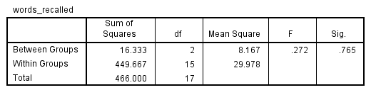

UNIANOVA words_recalled BY word_type

/PLOT=PROFILE(word_type)

/PRINT=ETASQ DESCRIPTIVE

/DESIGN=word_type.

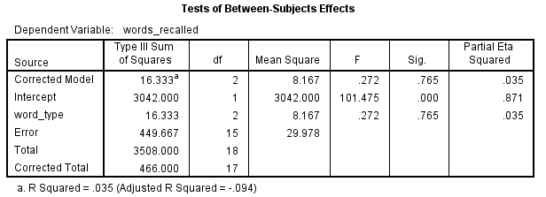

2-way independent ANOVA: depression & word type

UNIANOVA words_recalled BY depression word_type

/PLOT=PROFILE(word_type*depression)

/PRINT=ETASQ DESCRIPTIVE

/DESIGN=depression word_type depression*word_type.

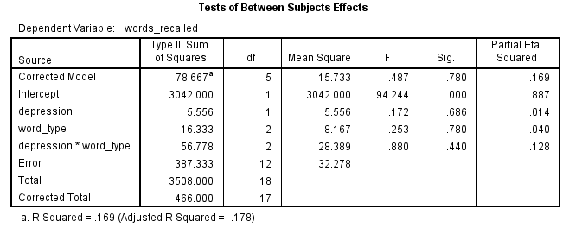

1-way RM ANOVA: just word type

GLM neutral positive negative

/PLOT=PROFILE(type)

/PRINT=DESCRIPTIVE ETASQ OPOWER HOMOGENEITY

/WSDESIGN=type.

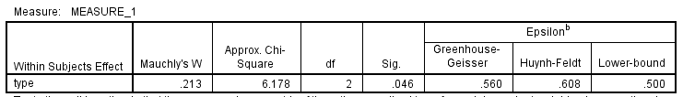

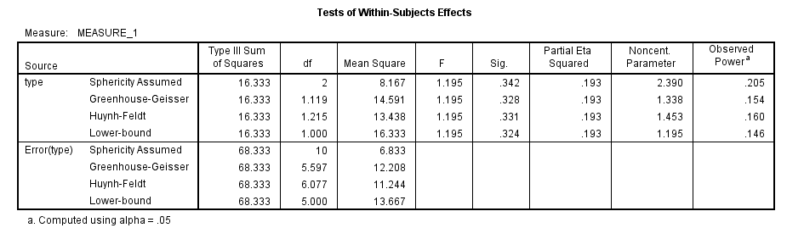

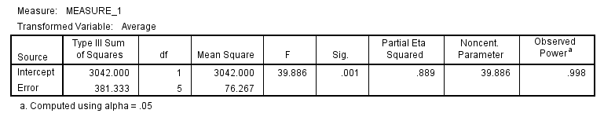

2-way Mixed Design ANOVA: depression & word type

GLM neutral positive negative BY depression

/PLOT=PROFILE(type*depression)

/PRINT=DESCRIPTIVE ETASQ OPOWER HOMOGENEITY

/WSDESIGN=type

/DESIGN=depression.

